**DAILY ONLINE ACTIVITIES SUMMARY**

|  |  |  |  |  |  |  |  |  |
| --- | --- | --- | --- | --- | --- | --- | --- | --- |
| **Date:** | **17/06/2020** | | | | | **Name:** | **Raksha S** | |
| **Sem & Sec** | **6th /B** | | | | | **USN:** | **4AL17CS073** | |
| **Online Test Summary** | | | | | | | | |
| **Subject** | | **Programming in C** | | | | | | |
| **Max. Marks** | | **15** | | **Score** | | | **12** | |
| **Pre-Placement Training Summary** | | | | | | | | |
| **Pre placement training** | **9:15 am to 11:00 am - Programming in C**  **11:00 am to 1:30pm - Applications of python in DA and ML** | | | | | | | |
| **Faculty** | | | Mr.Vivek Sharma **Dr.Mohideen Badusha** | | **Duration** | | | **4 hr** |
| **Assessments** | | | | | | | | |
| **Problem Statement:**   1. Examples and Exercises on python. | | | | | | | | |
| **Status: Completed** | | | | | | | | |
| **Uploaded the report in GitHub** | | | | | **Yes** | | | |
| **If yes Repository name** | | | | | <https://github.com/raksha05/Daily-Status>/Raksha-4AL17CS073/Raksha | | | |
| **Uploaded the report in slack** | | | | | **Yes** | | | |

**C quiz:**

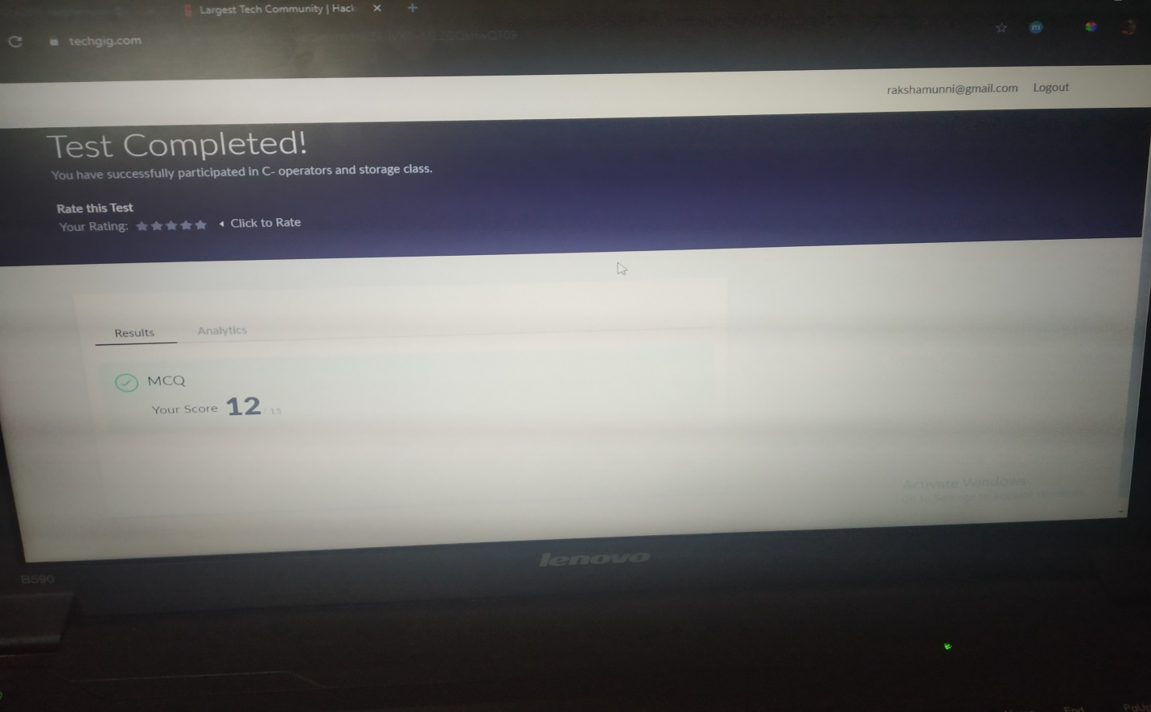

**Training snapshots:**

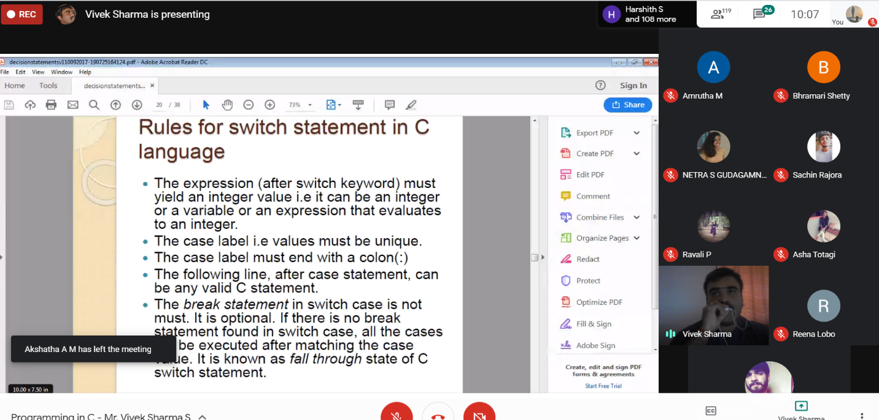

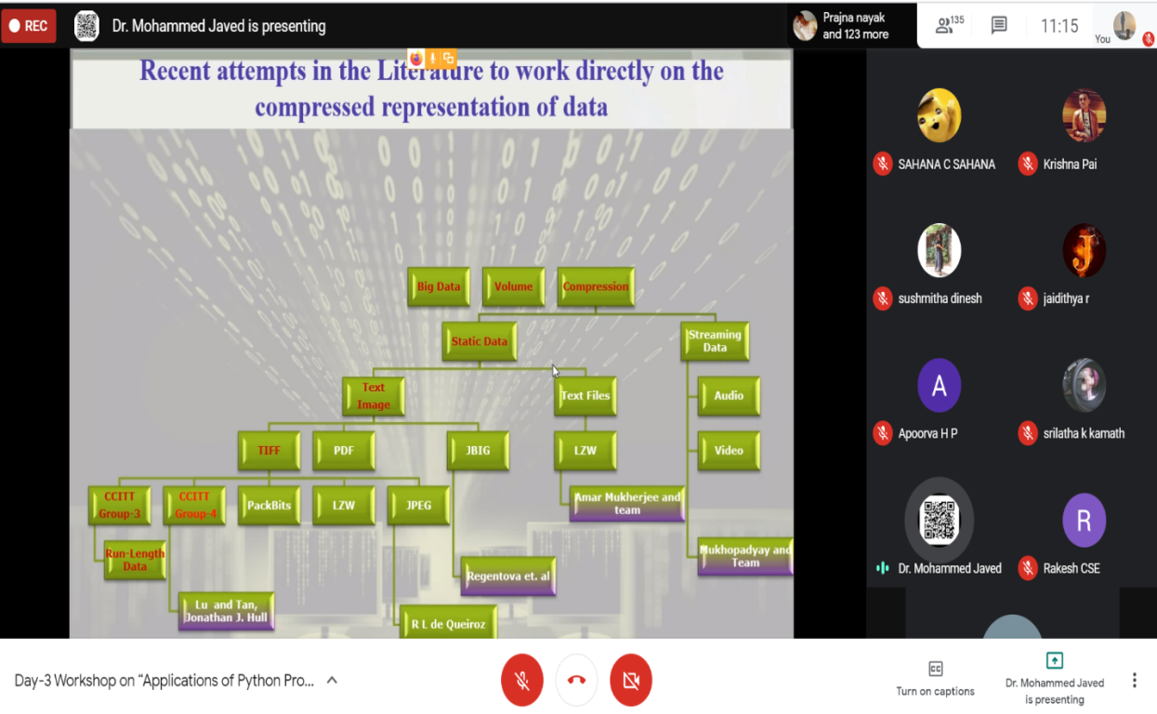

**Assessment :**

1.Python exercises

